Renju lesson on June 28, 2001

Hello all! Welcome to Online Renju Class. Today we will start learning the new 12th moves. You have been waiting it for a long time. Which are those two new 12th moves? You all have excellent memory – k7 and h10 are those two 12th moves indeed.
But do you also remember, we discussed that the conclusion about those 12th moves is not certain. And we said it will be our teamwork to find out the truth. Right?
I have done some work already and I have some conclusions already. Lets try k7 first.
One thing I must remind you. Moves k7 and h10 will be played in coming WC.
Therefore, if I tell my analyses here now, I risk that my opponents will know about it, and that is not good for me. Therefore I suggest we will study other 12th moves until WC is over. Thank you!

Move 12-j9. A famous move. It was actively played in 1997. And even a year after, in 1998, it was still popular. More and more people gave up this variant being convinced that black wins in that variant. I was one of the last fans of white color in this variant. I developed many strong blocks for white.. but after some time, all my blocks were killed.
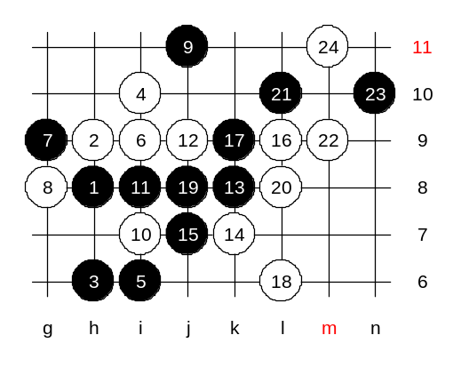
I will show you the main path. If white lets black take the L6 point then black wins fast, therefore white plays a three to occupy the L6 point. Do you know why black plays L10 now? The reason of L10 is to create two winning areas for black. Before, the people used the 22-m9 to try to block the upper side. 23 where? Remember, if black plays j6 and that move doesn’t win the black gives up both lower and upper side power. So be careful. Move 23-n10 is strong – it keeps both upper and lower side alive. Now black has two areas. Upper side is more dangerous, lets block it.
You want to see the win? Good. This will be your advanced level homework, please find the black win.

Now I show you my block that I invented after WC 97. Move m8 was my analysis after WC 97. It is interesting to see in database records that Nakamura was using that move in 1998, too.
I won couple of times as white in this variant until Tarannikov from Russia proved black sure win here. So I lost a game to him in this variant.
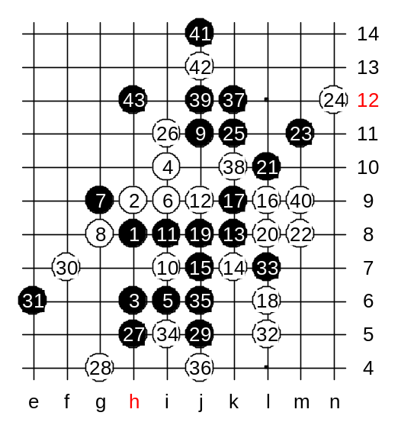
He used my own tactics that I had taught you before: Black tried to keep alive two areas, and white used one area to control both areas. Then, black tactics was to sacrifice one area in order to attack in another area. Remember, we discussed this tactics in d3 opening?
Black will attack in both areas, and will finally sacrifice lower area to block an important white defense line, and then black will win easily above.
Lets play just in the way Tarannikov played against me. J5 – good move. White moves below are all forced. Finally, black takes j6 point.
Now that black has a stone at j6, white line k7_L8 is dead, and white has no control over black line L10_k11 anymore. So you see, black sacrificed the whole lower side in order to block the white defense line k7_L8_m9. Now black wins easily in upper side.

Now, lets try the variant where white doesn’t take the L6 point. Lets play h5. Of course, blacks wants L6 immediately. White is forced to play L8.
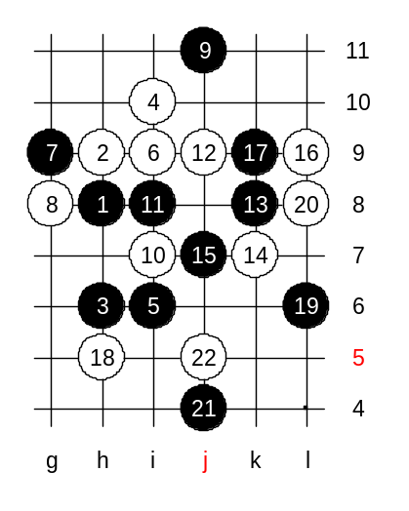
Black cannot attack directly with j6, therefore the space development j4 is needed. We give up the j6 point knowing that we have the control at i5 point, and maintain the needed space.
Now white plays j5.
This is the medium level homework. Please find the black win.

